INSTALLING AND SETTING UP KARMA

This document guides:

* How to install Karma in Window environment?
* How to configure Karma to test AngularJS?

# Installing Karma

You need to install nodejs at <http://nodejs.org> into your local machine. Installing nodejs also installs npm at <https://www.npmjs.org/>.

**Installing Karma with global mode**

We need Karma with global mode to run Karma at every directories (every projects).

Karma is a Javascript library. To install it, we use command line as

*/> npm install -g karma-cli*

This command line will install Karma the directory of current user. After finishing installing, you can check at:

c:\Users\{userName}\AppData\Roaming\npm\node_modules\karma-cli

**Installing Karma for each projects**

*Note: There are two ways to use Karma*

*1) Installing Karma for each project.*

*2) Setting up system environment variable to point to Karma-cli directory.*

To install Karma for each project, you go to the source directory of your project. This directory contains node_modules. You run below command line:

*/> npm install karma --save-dev*

After that, you can check at:

{your_project_directory}\node_modules\karma

You can check Karma version with command line:

*/> karma --version*

# Initializing Karma

Karma configuration is setting up in file karma.conf.js. You can create this file manually. You also can generate it automatically.

You can run below command to generate it:

*/> karma init*

This command will show you a screen to select multiple options. This is an example:

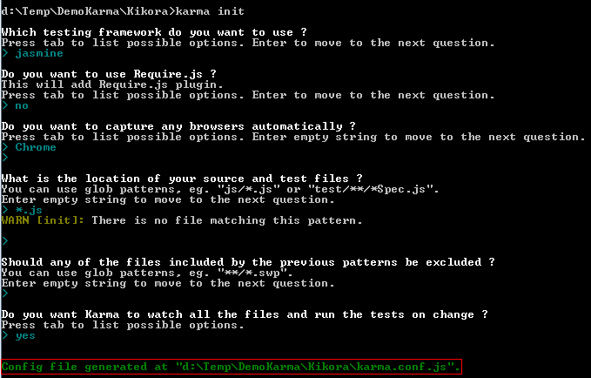

It will create new file karma.conf.js for you.

# Setting up Karma

There are multiple option to configure Karma.

*// frameworks to use  
// available frameworks: https://npmjs.org/browse/keyword/karma-adapter  
frameworks: ['jasmine'],*

With frameworks, you can use “jasmine”and “requirejs”.